**Wireframe Document**

**Amazon Sales Data Analysis**

WIREFRAME DOCUMENT DESIGN

**Document Control**

|  |  |  |  |
| --- | --- | --- | --- |
| **Date** | **Version** | **Description** | **Author** |
|  |  |  |  |
| 21/07/2022 | 1.0 | Introduction, | Rajat Chauhan |
|  |  | Problem Statement |  |
|  |  |  |  |
| 02/08/2022 | 1.1 | Dataset Information, | Rajat Chauhan |
|  |  | Architecture |  |
|  |  | Description |  |
|  |  |  |  |
| 12/08/2022 | 1.2 | Final Revision | Rajat Chauhan |
|  |  |  |  |



WIREFRAME DOCUMENT DESIGN

**We Performed Exploratory Data Analysis on Jupyter Notebook and then created a Tableau Desktop Dashboard.**

Chart 1

* Maximum Profit is seen for the year 2012
* Profit mostly kept on decreasing after 2012

Chart 2

* Most of the total profit is received for month Feb and Nov
* Least for Mar and Aug

Chart 3

* We can observe a sharp peak between the year 2013 and 2014

Chart 4

* Most of the units are sold for items – Cosmetics and Clothes
* Least for items- meat and snacks

WIREFRAME DOCUMENT DESIGN

Chart 5

* Profit of Cosmetics items is comparatively very high.
* Least for food items such as fruits , beverages and meat etc.

WIREFRAME DOCUMENT DES

Chart 6

Units Sold vs Regions

* Sub-Saharan Africa have most units sold
* Least can be seen in North America

WIREFRAME DOCUMENT DESIGN

Chart 7

Units Sold in Different Countries

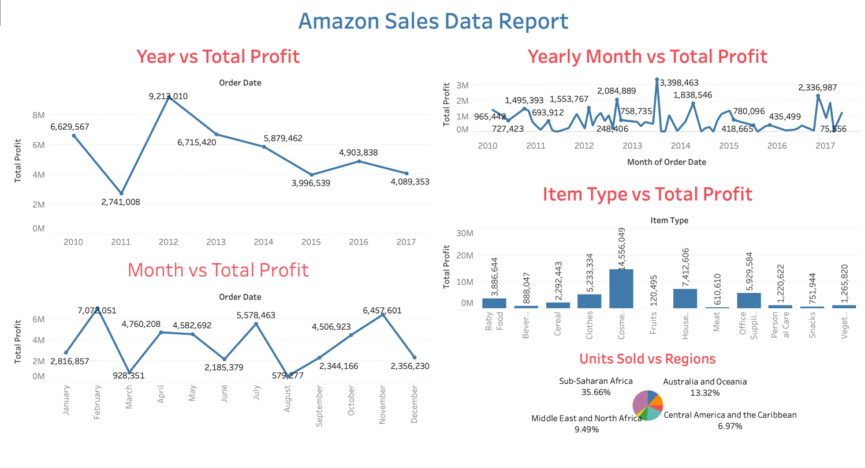

Key Performance Indicators

1. Unit Profit of Items

2. Units Sold by Items, regions

3. Total Profit by Year, Month, Yearly Months

Conclusions

1. Maximum total profit appears in months Feb and Nov , and least in Mar and Aug
2. The total profit is maximum for year 2012 and least in 2011
3. Most profitable item is cosmetics and least profitable are food items such as Fruits, beverages and meat.
4. Most of the item types are Clothes, Cosmetics and Office Supplies
5. The most units are sold in regions Sub-Saharan Africa (37) and Europe (24).
6. Most of the shipping is happening on Saturdays and Wednesdays and least on Sundays